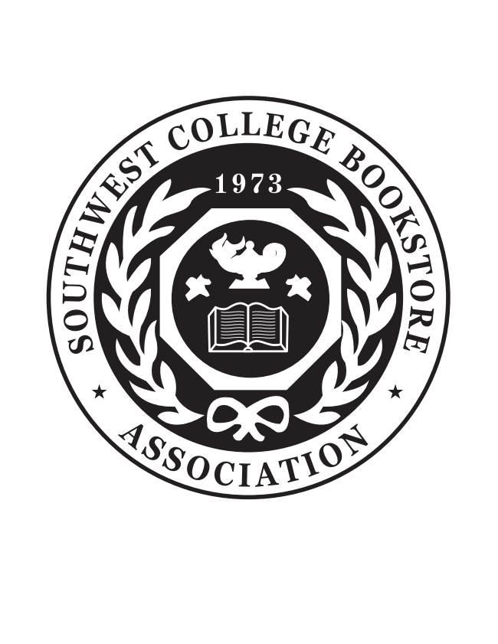
Store Registration
SWCBA Regional Meeting 2024
October 20 – 22, 2024
Oklahoma State University
Atherton Hotel
202 S Hester, Stillwater, OK 74078

A. FULL REGISTRATION $325 by August 31st $375 after August 31st
Includes ALL Ticketed Events: Opening Night Event, Vendor Appreciation Luncheon, and Closing Night, Education Sessions, Trade Show

B. PARTIAL REGISTRATION $225 by August 31st $275 after August 31st
Includes Closing Night, Vendor Appreciation Luncheon, Education Sessions, Trade Show

C. DAY BADGE $125 by August 31st $175 after August 31st
Includes Education Sessions, Trade Show

D. TRADE SHOW ONLY $25 by August 31st $35 after August 31st

E. GUEST BADGE (Non-Bookstore Personnel) $5 by September 21th $15 after September 21st
Includes free admission to Trade Show and Education Sessions (NO Food Included)

Additional Tickets:
Opening Night _____ x $65.00 = _________
Vendor Appreciation Luncheon _____ x $40.00 = _________
Closing Night _____ x $60.00 = _________

Total $ _________

SCHOOL NAME: ___________________________________________________________________

City: ________________________________________ State: __________ Zip Code: ______________

Registration Choice: A____ B____ C____ D____ E____ (please check)

______________________________ ___________________________________ $ _________
Name Email
TOTAL AMOUNT ENCLOSED $ _________

Special Dietary Needs: ____ vegetarian ____ diabetic ____ other

I understand the fee is per person cost for registration and that payment is to accompany this form unless due to limitations or regulations within my state or institutions.

______ Check enclosed
______ Payment paid on site
______ Invoice store (Payment to be made within 30 days)

Visa/MC/AmEx Number _________________________________________ Exp Date: ____________

CCV (security code on back of card):________ Billing Zip Code: __________________

Signature: _________________________________________________________________

Please complete form and forward to Starla Marshall, 5301 S Eagle Rd, Yale, OK 74085 or email to swcba@swcba.com or fax to 314-754-2667.

