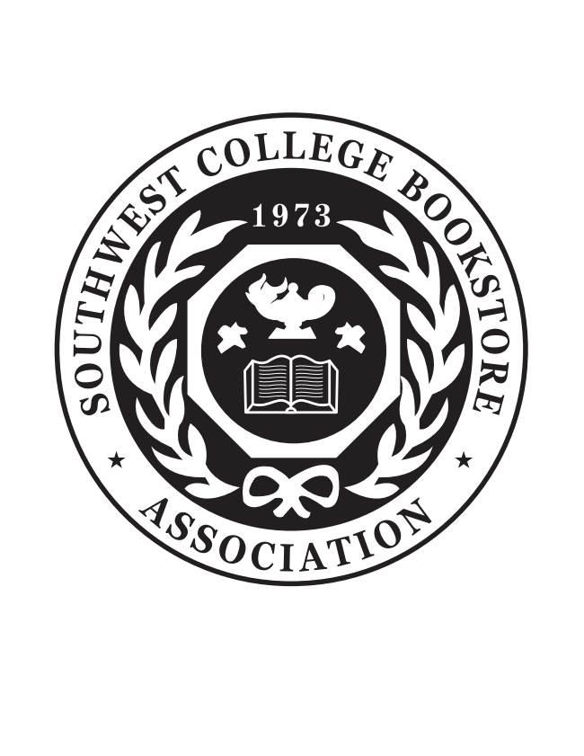
SWCBA Regional Meeting 2024
October 20 – 22, 2024

Oklahoma State University

Atherton Hotel

202 S Hester, Stillwater, OK 74078

VENDOR REGISTRATION FORM
Please reserve a table for our firm at the Southwest College Bookstore Association Meeting. I understand that exhibitors must be current members in good standing with the SWCBA.

Full registration includes: one 6’ skirted table, two chairs and company sign, one ticket for the Vendor Appreciation Luncheon at the tradeshow, and one Opening Night Ticket and Closing Night ticket (each with one set of refreshment tickets). The trade show is scheduled for Monday, October 21, 2024 from 1:30pm – 4:00pm.

Company Name: ____________________________________________________________________________________

Name: ________________________________________ Email: _________________________________________
Company Representative attending meeting to receive full registration packet.

Do you plan to stay at the meeting host hotel? ______ Yes _______ No
Full registration(s) ONE PER FIRM REQUIRED _____ X $425.00 = $_________
Registration after September 13, 2024 _____ X $475.00 = $_________
Additional Table request _____ X $100.00 = $_________
Electric: (Free but please indicate it you need electric on form) _____ X $0 = $ ________
Wi-Fi (Basic is free)
Height of Booth? (Please indicate if your booth sets on the table or if it sits on the floor) Table____ Floor____
Additional Name Badges request for company representatives attending meeting
Name: _________________________ Email: _________________________ ______ X $5.00 = $_________
Name: _________________________ Email: _________________________ ______ X $5.00 = $_________

Additional Tickets:
Opening Night Sunday, October 20, 2024 ______ X $65.00 = $_________

Vendor Appreciation Luncheon Monday, October 21, 2024 Buddy Ticket ______ FREE
(One free buddy ticket with each full registration for an additional company employee)

Vendor Appreciation Luncheon Monday, October 21, 2024 ______ X $40.00 = $_________

Closing Night Monday, October 21, 2024 _______ X $60.00 = $_________

Please attach a description of any special dietary needs or Total: $ _________
special accommodations to fully participate.
Method of Payment: _____ Check ____Visa _____Master Card _____Discover _____AmEx
Card Account Number: _______________________________________________________________________________ Expiration Date: _________________ CCV (security code on back of card):______________ Billing Zip Code: _________
Card Holder Name (Please Print): ______________________________________________________________________
Card Holder Signature: _______________________________________________________________________________
Phone # _____________________________________________ Fax: __________________________________________
Please Return Remittance and Registration Form to: SWCBA Office Attn: Starla Marshall 5301 S. Eagle Rd, Yale, OK 74085
Cell: 405-880-4131 Fax: 314-754-2667 or email swcba@swcba.com

