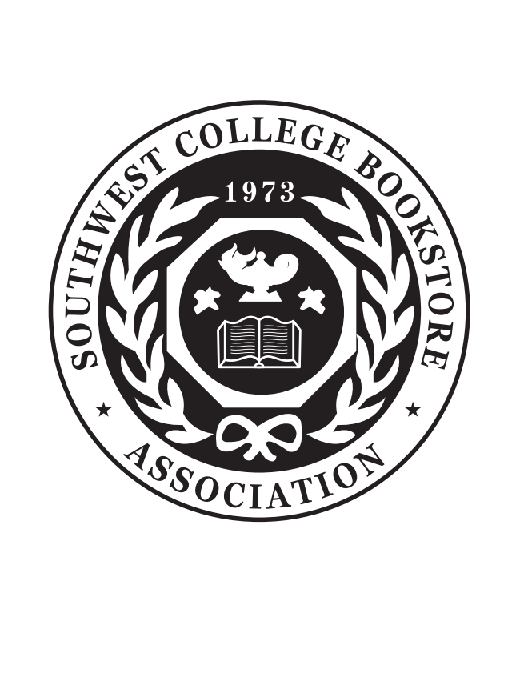

**Vendor Information**

**SWCBA Regional Meeting 2024**

**October 20 – 22, 2024**

**Oklahoma State University**

**Atherton Hotel**

**202 S Hester, Stillwater, OK 74078**

**Table Assignment**

Assignment of tables will be determined by the date the application and payment are received. Companies that wish to exhibit side by side must submit their applications together with an explanatory letter. Assignments will be limited to the first 65 applicants.

**Fees**

Table top fees are $425.00 with a second table available for $100.00. Payment in full must be received with Vendor registration. Wi-Fi is complimentary and electricity can be provided at no charge (first come first serve).

**Included in Your Fee**

Full registration includes one 6’ skirted table, two chairs and company sign, one ticket for the Vendor Appreciation Luncheon, Opening Night Ticket and Closing Night Festival ticket (each with one set of refreshment tickets).

**Booth Cancellations**

All cancellations must be received in writing. Request should be made to SWCBA Attn: Starla Marshall or via e-mail at [swcba@swcba.com](mailto:starla.marshall@okstate.edu) . If cancellation request is received on or before August 31, 2024 the exhibitor will receive an 80% refund of total booth fee. Exhibitors submitting cancellation requests between September 1, 2024 and October 1, 2024 will receive a 50% refund of total booth fee. No refunds will be given on cancellations made after October 1, 2024. Refunds due to cancellations will be paid within 45 days of receipt of written cancellation request.

**Hotel Reservations**

**(Please advise if you are staying at a separate hotel on registration form)**

Southwest College Bookstore Association members attending the meeting are responsible for making their own hotel reservations. The SWCBA has a special group rate of: $109.95 (plus appropriated tax) per night for queens; $119.95 for kings, doubles, queen suites and king suites. Please identify yourself as a member of the Southwest College Bookstore Association when making your reservations. Please make hotel reservations by calling 405-744-6835**.**

**Parking Facilities**

Valet special rate of $10.00 per day or the Student Union Parking Garage for $15.00 per day.

**Shipping and Receiving**

If you need to ship anything for the tradeshow, you may ship for arrival October 9 - 13, 2024 (No Saturday deliveries) to:

SWCBA

c/o Cherry Bailey

120 Student Union

Stillwater, OK 74078

(Box __ of __ )

**Questions?** Contact Starla Marshall at [swcba@swcba.com](mailto:swcba@swcba.com) or 405-880-4131.